

**BINARY TO DECIMAL CONVERSION CALCULATOR USING 7-SEGMENT DISPLAY**

Name/ Ezeldin Mohamed Mansour Mansour

Matric Number/ 1721667

**1.0 Introduction:**

In this project we will study the functioning of Binary to Decimal Converter by using IC 7447.Four toggle switches are used to give binary number as an input. At Output Side a seven-segment display is used to show the decimal numbers from 0 to 9. Normally we count on the scale of ten or decimal system using the ten digits 0 to 9. When the count exceeds 9, we place a 1 in a second column to the left of the unit’s column to represent tens. A third column to the left of the ten’s column gives hundreds and so on. The values of successive columns starting from the right are 1,10,100, etc, or in powers of ten, 100 ,101, 102, etc. Counting in electronic systems is done by digital (i.e., two state) circuits on the scale of two or binary system using the digits (bits) 0 and 1 which are usually represented by ‘low and ‘high voltage levels, respectively. Many more columns are required since the number after 1 in binary is 10, such as 2 in decimal, but the digit 2 is not used in the binary system.

In this project, a circuit is designed using logic gates for purpose of converting binary to decimal.

**1.1 Objectives:**

The main objectives of this project is to:

* Implement class learning to the practical life.
* Implement critical thinking ability and design complex logic circuit in real life.

**2.0 Design Process**

Design steps are described below:

1. Making of truth table for numerical designation for 7-segment display for

0-9.

1. Making of K-map for each segment of the 7-segment display.
2. Getting Boolean expression from the K-map for each segment.
3. Making Logic circuit for each segment of the 7-segment display.
4. Combining of all the logic circuit for each segment together and make a complete circuit for binary to decimal conversion calculator.
5. Final check if the designed circuit is working properly or not.

**3.0 Detailed Design**

Detailed design of the binary to decimal conversion calculator is given below including truth table, k-maps, Boolean expression and logic circuits.

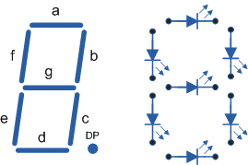

Figure 1: 7-segment display designation

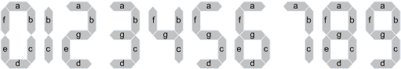

Figure 2: Numerical designation for the display

Table 1: Truth Table for 7-segment display

|  |  |  |  |  |  |  |  |  |  |  |  |  |
| --- | --- | --- | --- | --- | --- | --- | --- | --- | --- | --- | --- | --- |
| Binary Input | | | |  | Decoder Output | | | | | | | 7-Segment  Display Output |
| A | B | C | D | a | b | c | d | e | f | g |  |
| 0 | 0 | 0 | 0 | 1 | 1 | 1 | 1 | 1 | 1 | 0 | 0 |
| 0 | 0 | 0 | 1 | 0 | 1 | 1 | 0 | 0 | 0 | 0 | 1 |
| 0 | 0 | 1 | 0 | 1 | 1 | 0 | 1 | 1 | 0 | 1 | 2 |
| 0 | 0 | 1 | 1 | 1 | 1 | 1 | 1 | 0 | 0 | 1 | 3 |
| 0 | 1 | 0 | 0 | 0 | 1 | 1 | 0 | 0 | 1 | 1 | 4 |
| 0 | 1 | 0 | 1 | 1 | 0 | 1 | 1 | 0 | 1 | 1 | 5 |
| 0 | 1 | 1 | 0 | 1 | 0 | 1 | 1 | 1 | 1 | 1 | 6 |
| 0 | 1 | 1 | 1 | 1 | 1 | 1 | 0 | 0 | 0 | 0 | 7 |
| 1 | 0 | 0 | 0 | 1 | 1 | 1 | 1 | 1 | 1 | 1 | 8 |
| 1 | 0 | 0 | 1 | 1 | 1 | 1 | 1 | 0 | 1 | 1 | 9 |

Karnaugh map:

1. Karnaugh map and logic circuit for “a”

Boolean expression = $\overline{B}\overline{D}+C+BD+A$

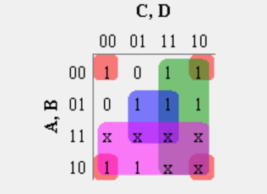

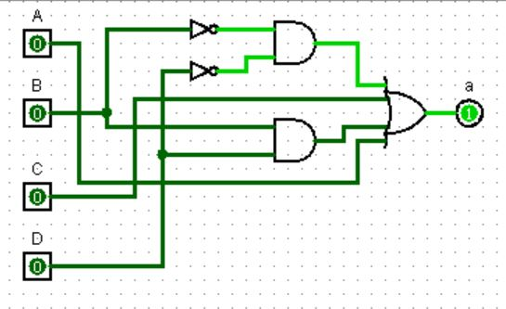

Figure 3: Karnaugh map and logic circuit for segment “a”

2. Karnaugh map and logic circuit for “b”

Boolean expression = $\overline{B}+\overline{C}\overline{D}+CD$

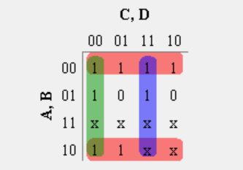

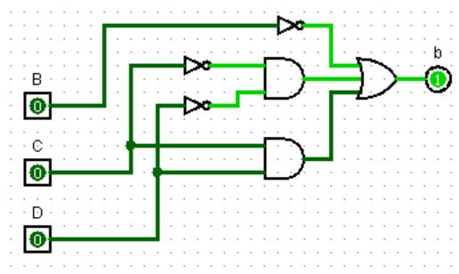

Figure 4: Karnaugh map and logic circuit for segment “b”

3. Karnaugh map and logic circuit for “c”

Boolean expression = $\overline{C}+D+B$

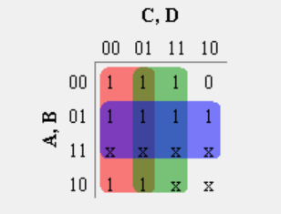

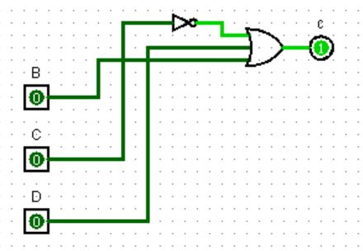

Figure 5: Karnaugh map and logic circuit for segment “c”

4. Karnaugh map and logic circuit for “d”

Boolean expression = $\overline{B}\overline{D}+ \overline{B}C+C\overline{D}+B\overline{C}D+A$

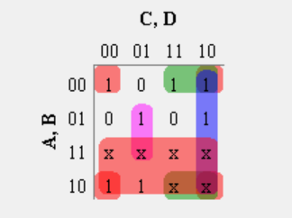

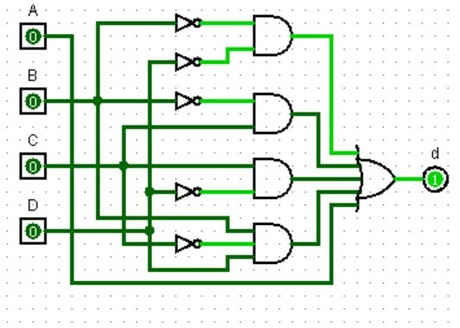

Figure 6: Karnaugh map and logic circuit for segment “d”

5. Karnaugh map and logic circuit for “e”

Boolean expression = $\overline{B}\overline{D}+C\overline{D}$

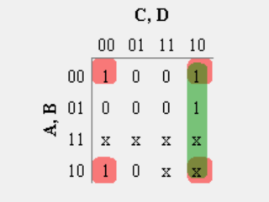

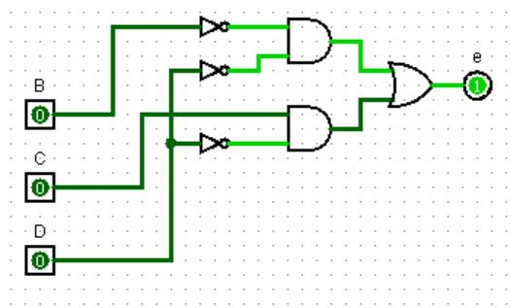

Figure 7: Karnaugh map and logic circuit for segment “e”

6. Karnaugh and logic circuit map for “f”

Boolean expression = $\overline{C}\overline{D}+B\overline{C}+B\overline{D}+A$

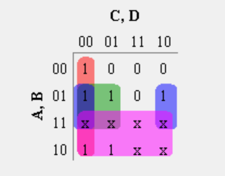

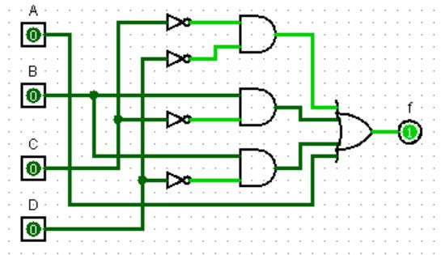

Figure 8: Karnaugh map and logic circuit for segment “f”

7. Karnaugh map and logic circuit for “g”

Boolean expression = $B\overline{C}+B\overline{C}+B\overline{D}+A$

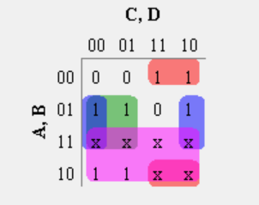

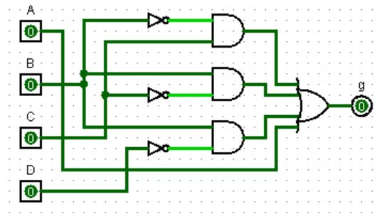

Figure 9: Karnaugh map and logic circuit for segment “f”

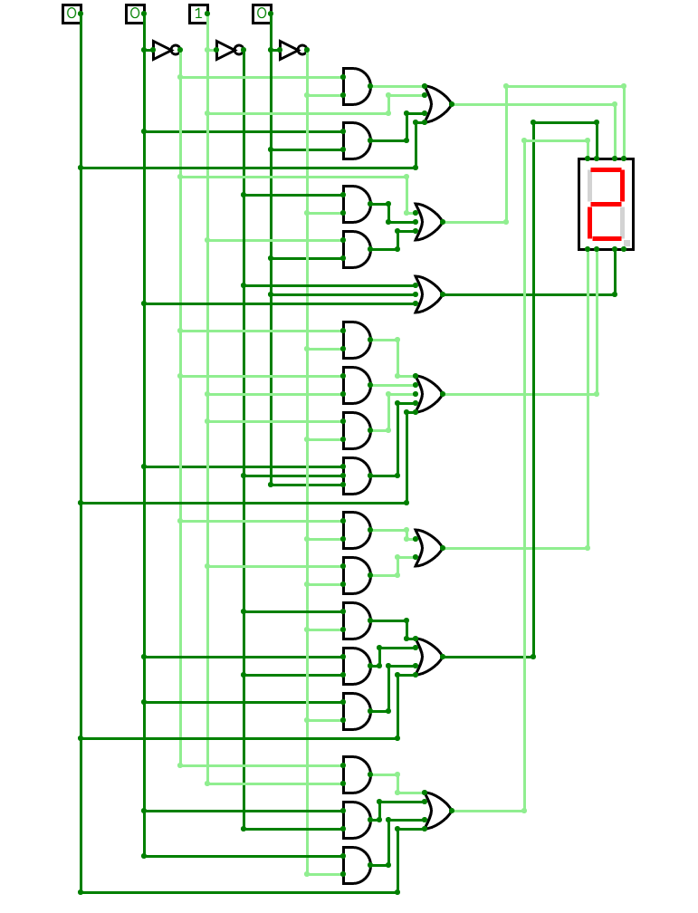

Figure 10: Complete Logic circuit with 7-Segment display.

**4.0 Conclusion**

In conclusion, it can be said the objectives of this project has been achieved and a binary to decimal conversion calculator is designed. The design has been verified using Logisim software and the system is working properly.